**ATTENUATOR AMPLIFIER BOARD PINOUT**

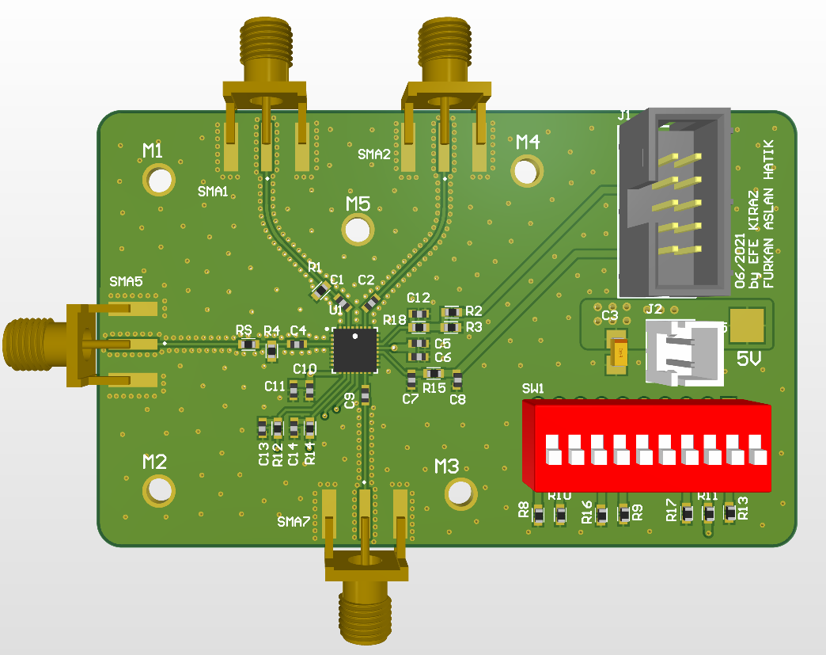

**2**

**1**

Figure 1: The pins of the board inside the box

|  |  |  |  |  |  |  |  |  |  |  |  |  |  |  |  |  |  |  |  |  |  |  |
| --- | --- | --- | --- | --- | --- | --- | --- | --- | --- | --- | --- | --- | --- | --- | --- | --- | --- | --- | --- | --- | --- | --- |
|  |  |  |  |  |  |  |  |  |  |  |  |  |  |  |  |  |  |  |  |  |  |  |
|  |  |  |  |  |  |  |  |  |  |  |  |  |  |  |  |  |  | 1 | 2 |  |  |  |
|  |  |  |  |  |  |  |  |  |  |  |  |  |  |  |  |  |  | 3 | 4 |  |  |  |
|  |  |  |  |  |  |  |  |  |  |  |  |  |  |  |  |  |  | 5 | 6 |  |  |  |
|  |  |  |  |  |  |  |  |  |  |  |  |  |  |  |  |  |  | 7 | 8 |  |  |  |
|  |  |  |  |  |  |  |  |  |  |  |  |  |  |  |  |  |  | 9 | 10 |  |  |  |
|  |  |  |  |  |  |  |  |  |  |  |  |  |  |  |  |  |  |  |  |  |  |  |
|  |  |  |  |  |  |  |  |  |  |  |  |  |  |  |  |  |  |  |  |  |  |  |
|  |  |  |  |  |  |  |  |  |  |  |  |  |  |  |  |  |  |  | 11 |  |  |  |
|  |  |  |  |  |  |  |  |  |  |  |  |  |  |  |  |  |  |  | 12 |  |  |  |
|  |  |  |  |  |  |  |  |  |  |  |  |  |  |  |  |  |  |  |  |  |  |  |

Table 1: Pin number and corresponding pin name

|  |  |  |  |
| --- | --- | --- | --- |
| Pin Number | Pin Name | Pin Number | Pin Name |
| 1 | GND | 7 | GND |
| 2 | GND | 8 | GND |
| 3 | V_MODE | 9 | V_CTRL |
| 4 | GND | 10 | GND |
| 5 | GND | 11 | 5V |
| 6 | STBY | 12 | GND |